**Homework 3 – Three Phase Transformers and Energy Conversion**

*This homework is to be solved using computational tools (such as MATLAB). You should show your work (how the resultant plot is obtained analytically, and required explanations). An example code is provided about using complex numbers in MATLAB.*

*A template is also provided. You should submit your homework by converting your .m file solution (from the template) to pdf by using* ***publish*** *command. Required explanations and several tips are given in the template.*

**Q.1.** A typical electricity delivery system is generally composed of generation, transmission and distribution parts as shown in Figure 1.

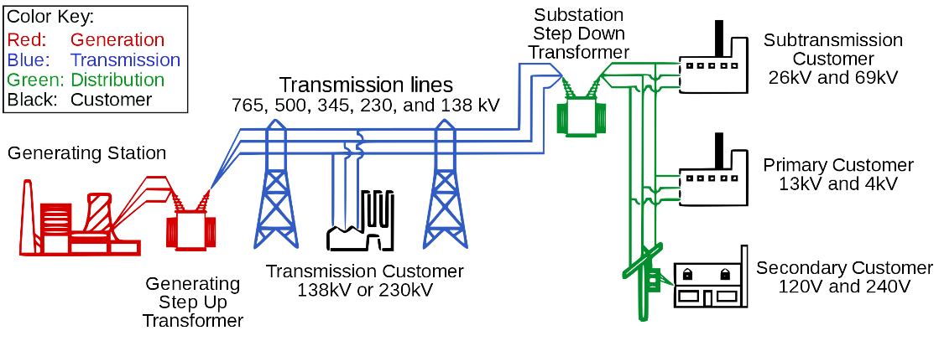

Figure 1: A typical electricity delivery system

In this question, you will consider a delivery system which starts from a hydroelectric power plant (Figure 2-a) in Samsun (Hasan Uğurlu Dam) and ends in Ankara. The medium voltage at the generation side is increased to high voltage level by a step up transformer substation (Figure 2-b), the energy is transferred via a 300 km transmission line (Figure 2-c), the voltage is decreased to distribution level in TEİAŞ step down transformer substation (Figure 2-d), and the energy is transferred to a couple of counties in Ankara via feeders (Figure 2-e). Single line diagram of the delivery system is shown in Figure 3.

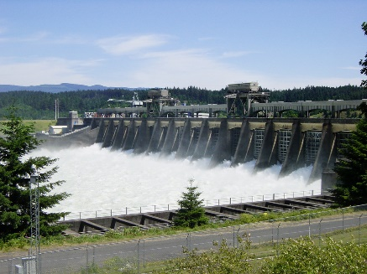 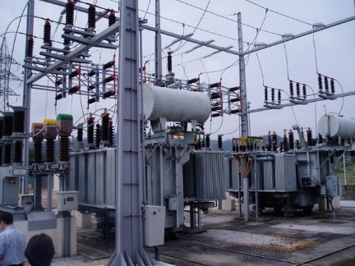 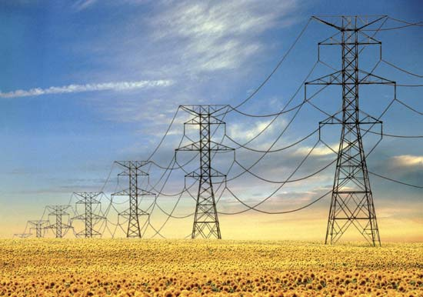

(a) (b) (c)

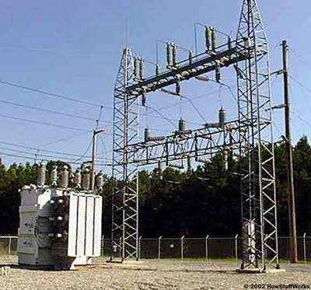 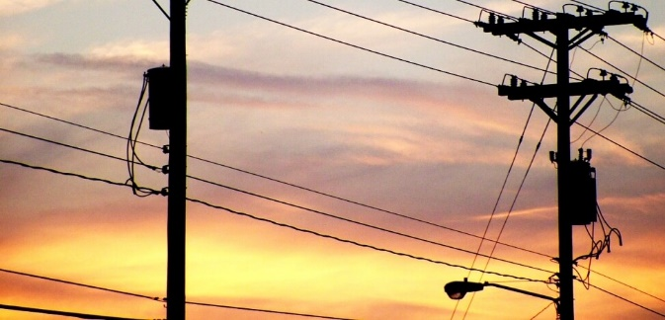

(d) (e)

Figure 2: Parts of an electricity delivery system



Figure 3. Single Line Diagram of the Electricity Delivery System

The system parameters are as follows:

**Generator:** You may assume an infinite bus (ideal source). 15kV line-to-line, 50 Hz.

**Feeder-1:** Zf1 = 5 + j45 mΩ/phase

**Step-up transformer:** 50 MVA, 15kV/154kV line-to-line. Zt1 = 20 + j225 mΩ/phase (referred to the primary side)

**Transmission line:** Ztline = 1 + j9.5 Ω/phase

**Step-down transformer:** 50 MVA, 154kV/34.5kV line-to-line. Zt2 = 15 + j60 Ω/phase (referred to the primary side)

**Feeder-2:** Zf2 = 25 + j240 mΩ/phase

**Load:** You may assume that the load is ***purely resistive*** throughout the question. The load profile for 24 hours is given in the attached file *“load_profile.xlsx”*.

**PART A:** *In this part, consider the load current at 7 p.m.*

1. Obtain the magnitude of the load voltage (line to line).
2. Obtain the load angle between the same phases of source voltage and load voltage.
3. Obtain the line current in feeder-1.
4. On the same figure, plot the ***three-phase source voltages*** for two fundamental cycles.
5. On the same figure, plot the ***three-phase line currents*** at ***feeder-1*** for two fundamental cycles.
6. On the same figure, plot the ***phase-A source voltage (line-to-neutral)*** and ***phase-A line current at feeder-1*** for two fundamental cycles.
7. On the same figure, plot the ***phase-A load voltage (line-to-neutral)*** and ***phase-A line current at feeder-2*** for two fundamental cycles.
8. Calculate the power factor at source terminals. Comment on the power factor.
9. Propose a method to correct the power factor found in (h).
10. How would your results change if the system frequency were 100 Hz, instead of 50 Hz? You do not have to calculate anything, but you need to provide analytical reasoning.

**PART B:** *In this part, consider the whole 24 hours period.*

1. Import the daily load profile data. Using **smooth** function on MATLAB, obtain a smoothed load profile and plot them on the same figure.
2. Obtain and plot the voltage magnitude (line-to-line) at the load terminals for 24 hours period.
3. Obtain and plot the voltage regulation at the load terminals for 24 hours period. Comment on the results.
4. Obtain and plot the overall efficiency of the system for 24 hours period. Comment on the results.
5. Calculate the total energy delivered to the load during 1 day, in MWh.

**Q.2.**Consider the electromechanical energy conversion device shown in Figure 2. The core can be assumed to have infinite permeability and it is fixed mechanically. The plunger core can also be assumed to be infinitely permeable and it can move vertically in a frictionless surface. The plunger has a mass of 20 kg. Rubber stopper is a non-magnetic material and its thickness is 1 cm. The spring balance is at x = 10 cm.

I = 45 A. N = 50 turns. A = 10 cm2. µ0 = 4π10-7 H/m. k = 100 N/m.



Figure 2: Electromechanical Energy Conversion Device

**a)** Obtain the reluctance and inductance ***as a function of displacement (x)***.

**b)** Obtain and plot the stored magnetic energy, in Joules, ***as a function of displacement***.

**c)** ***As a function of displacement,***

i) Obtain the electromagnetic force, in Newtons

ii) Obtain the spring force, in Newtons

iii) Obtain the force due to gravity, in Newtons

iv) Obtain the net force, in Newtons

acting on the mass.

v) Plot these forces as a function of displacement, on the same figure.

**d)** Obtain and plot the acceleration of the mass, in m/s2, ***as a function of displacement***.

**e)** Suppose that the mass is stationary at x = 15cm and then the current is applied at t=0. ***As a function of time***,

i) Obtain the acceleration, velocity and position of the mass.

ii) Plot the acceleration, velocity and position of the mass on the same axis, using **subplot**.

**f)** Comment on the operation of the device. How would it change when friction is not neglected?